Connecting to VDI from Off-Campus

Instructions are in two parts:

1st part is downloading/installing for Windows/Mac/Linux/iOS/Android.

2nd part is for configuring the VDI client for accessing removable devices.

Download the VMware Horizon View client

https://my.vmware.com/web/vmware/info?slug=desktop_end_user_computing/vmware_horizon_clients/5_0#

If web address is no longer functional, just Google “vmware horizon client download” and install, it’s small in size.

Select the appropriate version depending on the operating system of your device and click on Go to Downloads.
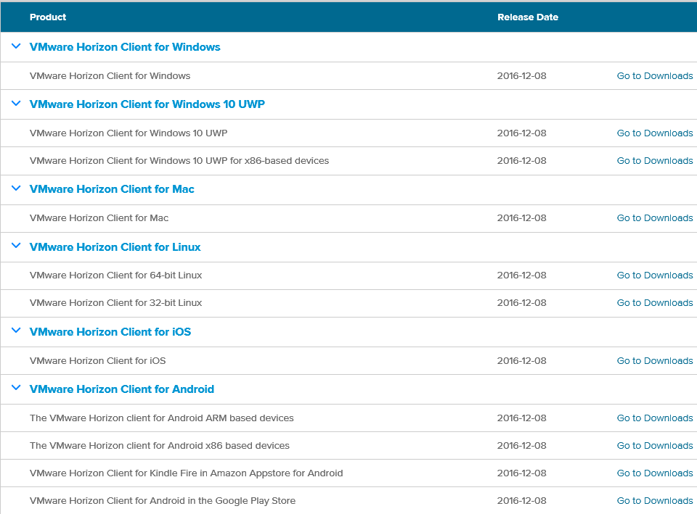

Windows installation

Click on Download, then look for the prompt at the bottom of your browser and click on Run.

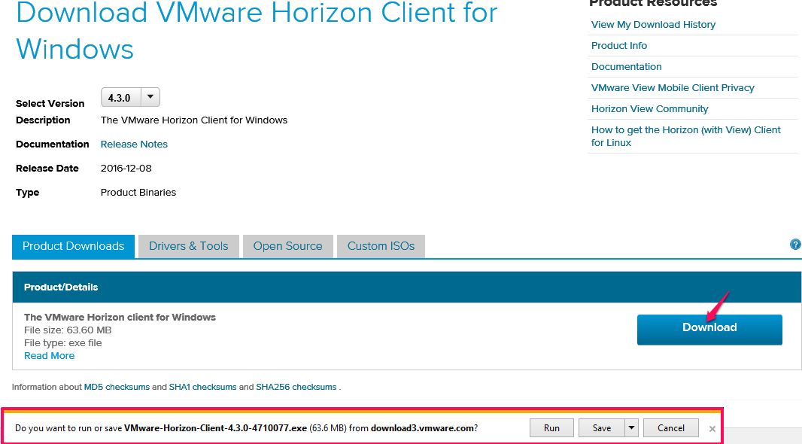

Take the default settings to install the VMware Horizon Client.
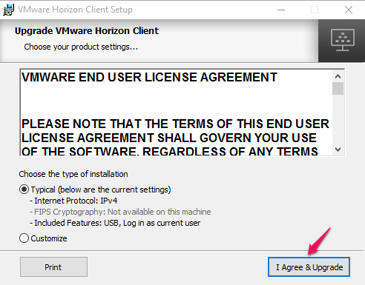

Restart your system.
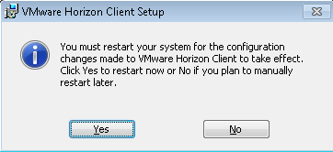

After the reboot, open the VMware Horizon Client on your Windows menu or desktop and click on Add Server.

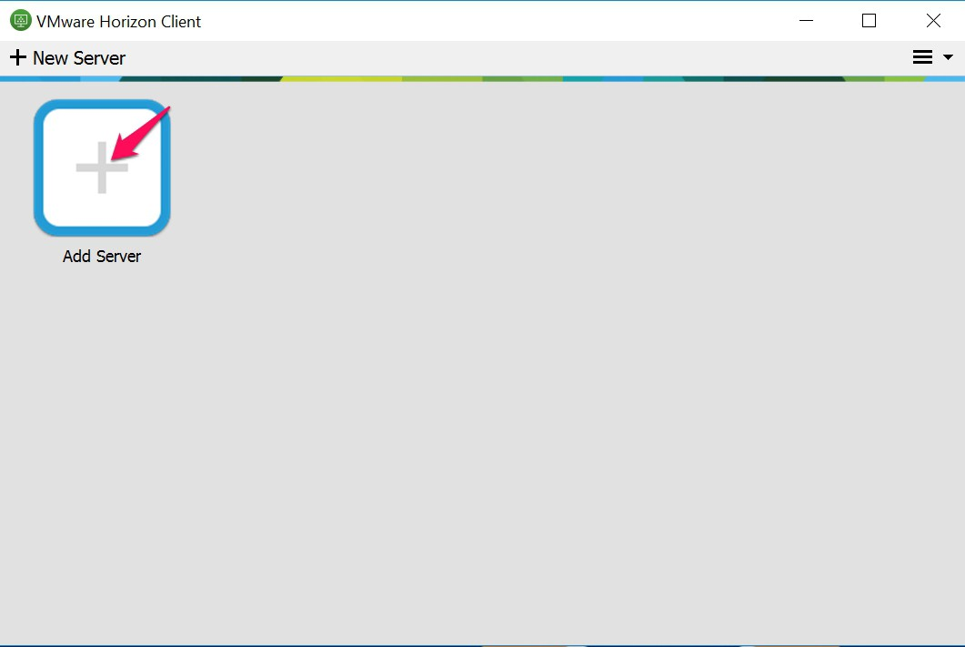

Enter mydesktop.cccd.edu when prompter for a new server.
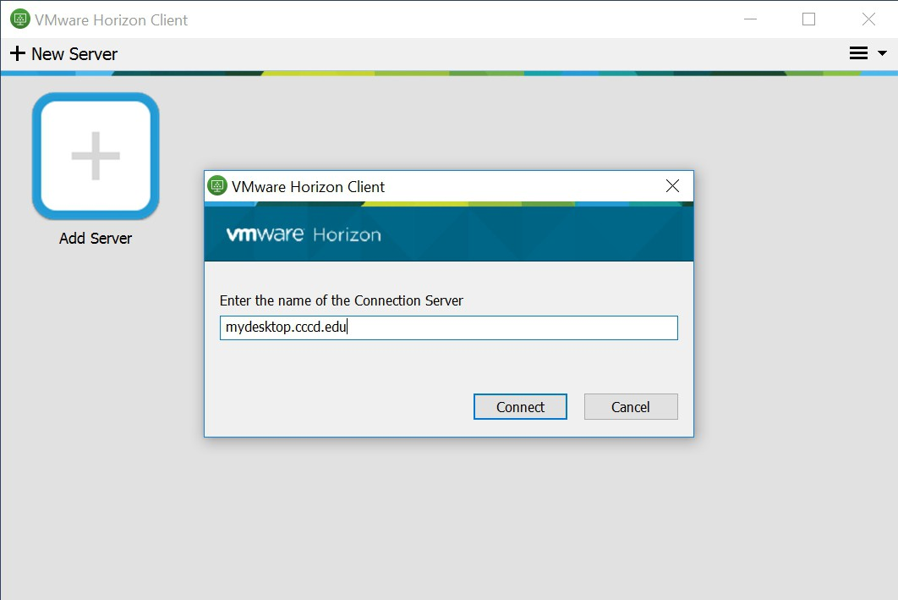

Enter your login credentials to the COAST domain.
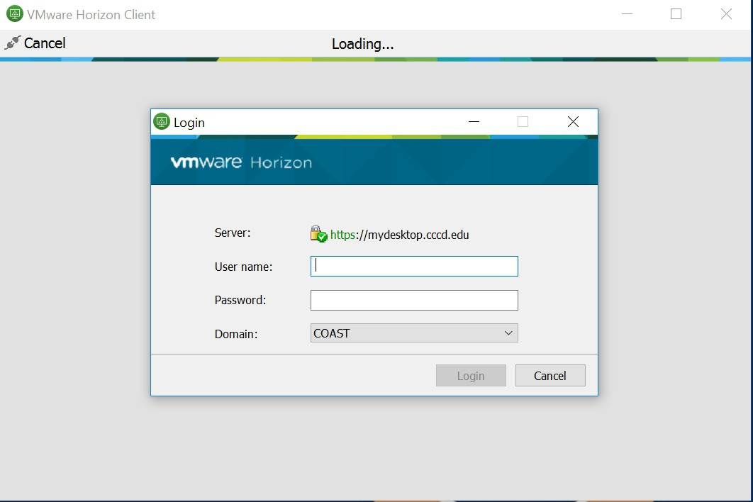

Double-click on OCC Remote to access your VDI desktop.
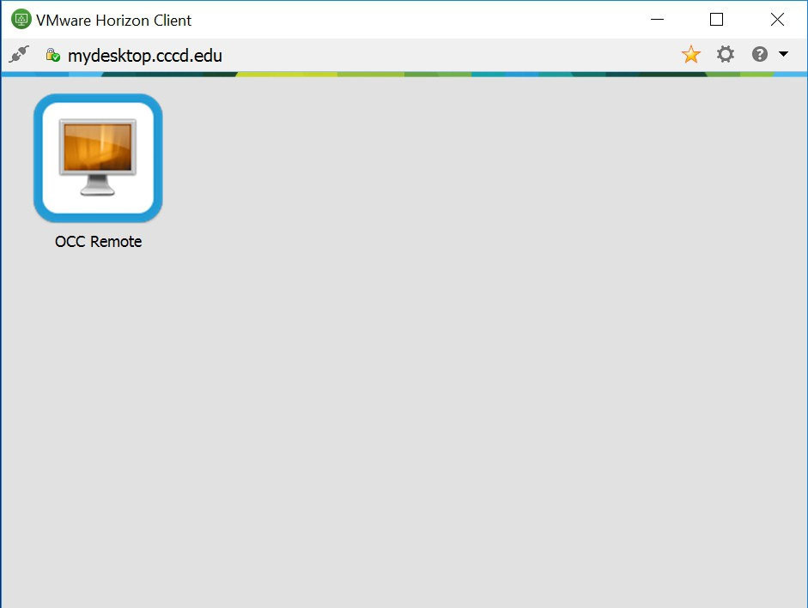

OCC-Open Lab OCC Adobe W10 OCC-TechClass
Microsoft Office Adobe Creative Cloud AutoCad Suite
MyMathLab ArcGIS FrameCAD
Programming software Microsoft Office Google Earth
Respondus Lock Down Brower MyMathLab Grasshopper
SPSS Programming software Mastercam
Visual Studio Quickbooks Sketchup
Respondus Lock Down Browser Solidworks
SPSS VRay
Visual Studio --misc associated apps

You can bypass the following instructions for Mac, if not applicable and move on to the next section for configuring the client for accessing removable devices.

Mac Installation

Open the dmg file and copy the application to the Application folder

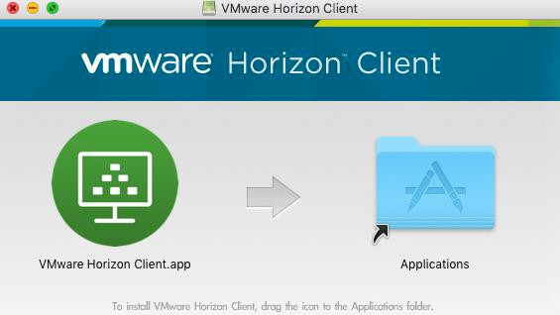

Open the application and add the server mydesktop.cccd.edu

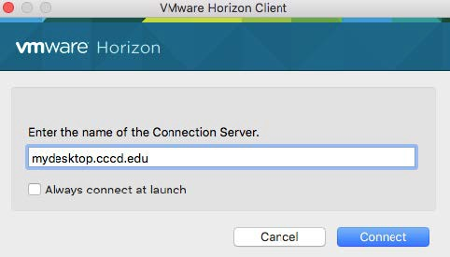

Now we move on to configuring the client for access to your removable storage.

Enabling / Re-Enabling Removable Storage in Horizon Client

- If you plan upon using a “flash”/removable drives within your VDI pool, you should’ve been prompted to Allow/Deny “removable media” upon successful login to your chosen VDI “pool. If this is the case, you want to choose “Allow”.
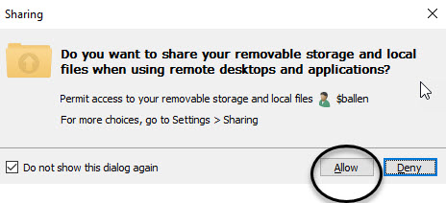

- If you chose Deny your “flash”/removable drive will not be visible within the VDI desktop and you won’t be prompted again because of the preselected “Do not show this dialog again” but you can correct this by following the steps below.

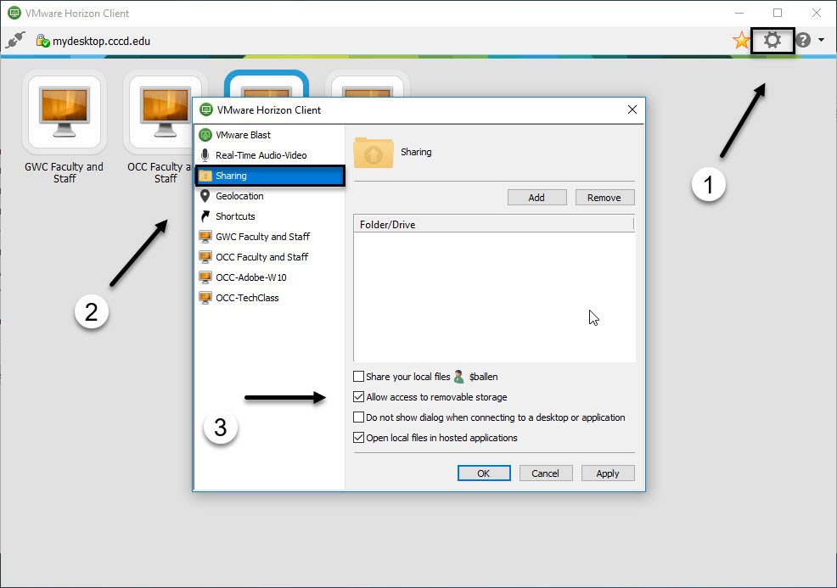

- Go back to the “VMWare Horizon Client” window.
- Using your mouse/touchpad, left click #1 which opens box #2
- Switch to menu choice “Sharing”
- Ensure “Allow access to removable store” is checked.

NOTE: This is a “Global” setting meaning it will apply to any VDI pool you have listed within your “VMware Horizon Client” screen

- Return to your VDI desktop and make the following change to ensure “flash”/removable drives are now viewable.

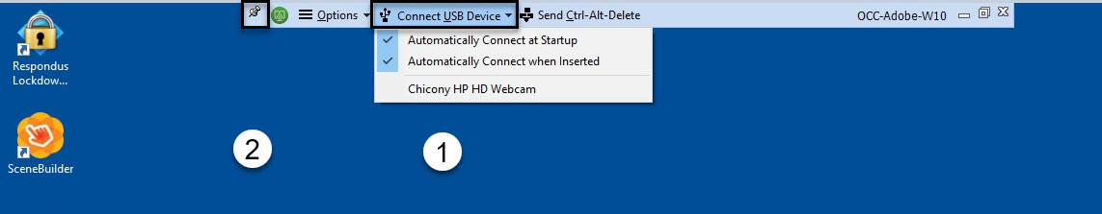

If you don’t see the above at the top-most part of your display screen, take your mouse all the way to the top-most edge of your screen and this should drop-down.

- Using your mouse/touch-pad, left click “Connect USB Device” and check both “connect” options
- You can also “pin” the above menu to the top of your screen if it doesn’t automatically stay put.

Your removable device should now be viewable within your VDI desktop. If it doesn’t, try “ejecting” and re-inserting it.

NOTE: In addition to using “removable devices”, you can use any of the browsers to log into a “cloud storage” of your choice (i.e. DropBox, OneDrive, Google Drive, etc.) and store your work there as well.

Courtesy of OCC IT (ADeLeon, MKline and BAllen)

